2.2 Web Hosting with EC2 and S3

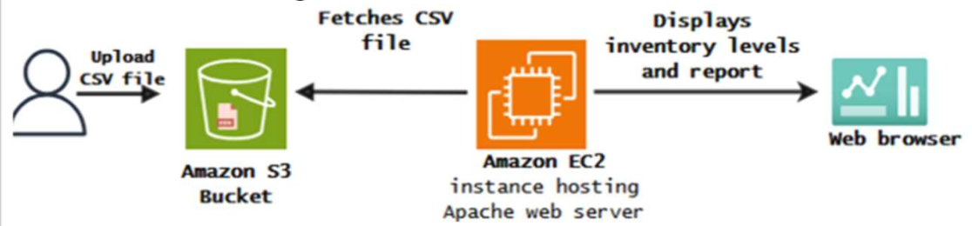

Objectives:
- Create S3 bucket and upload a file
- Create EC2 and Apache server
- Delete the services.

Part 1. Create an Amazon S3 Bucket

- Log onto AWS Console and click services.
- Click on S3 in Storage category.

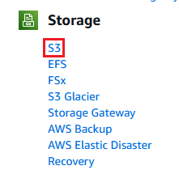

- Click on “Create bucket”.

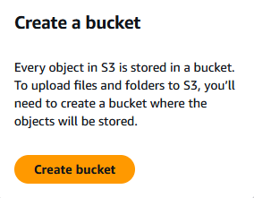
- Assign the bucket a name.

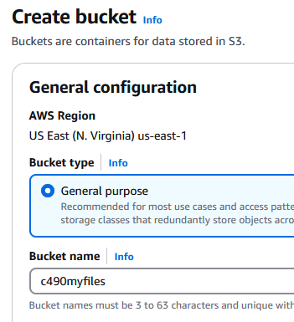

- Choose ACL enabled.

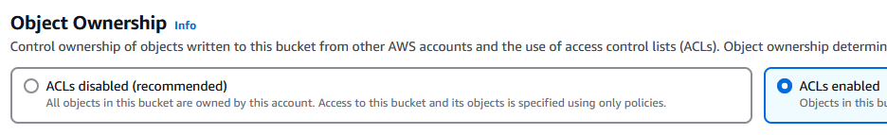

- Disable (uncheck) Block all public access. Acknowledge the risks.

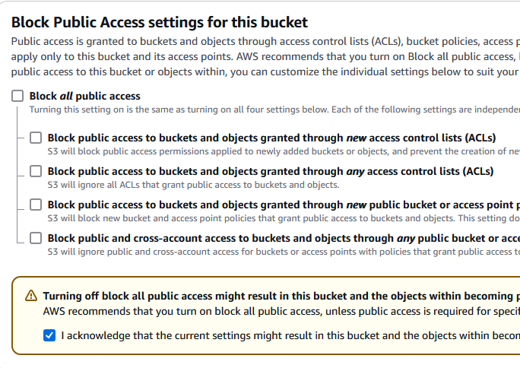

- Click on “Create bucket”



- Click on the bucket that is just created.

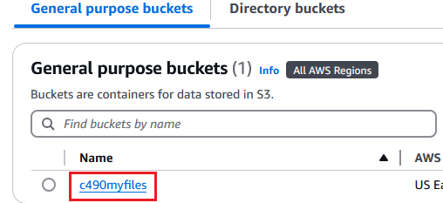

- Upload the csv file provided online. Click on “Upload”, “Add file”. Select the file and click on “Upload”.

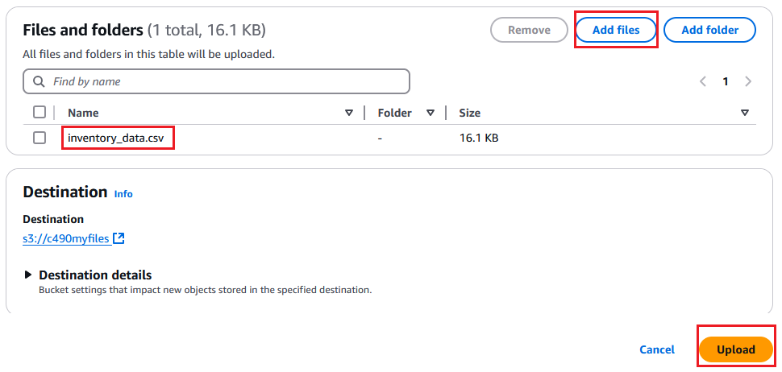

- Click on the file just uploaded.

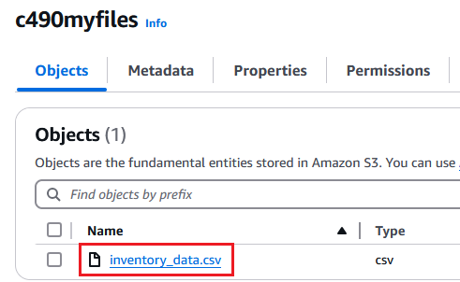
- Click on Permissions.

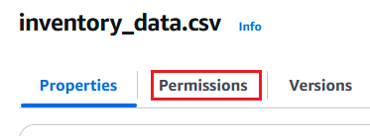

- Click on “Edit” and then assign read access. Click on “Save changes”.

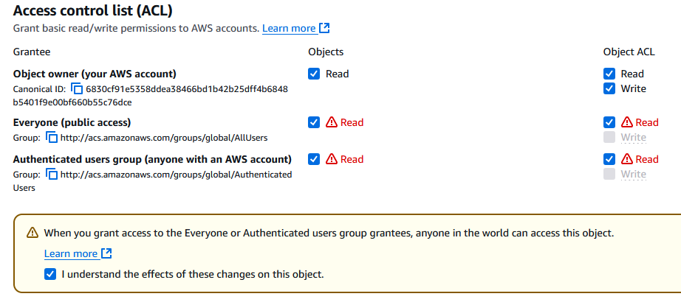

- Copy the object URL and paste it in a web browser. You should be able to see it or download it.

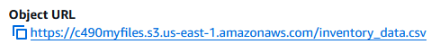

Part 2. Create an EC2

- Go back to your AWS console.
- From All Services, select EC2 in Compute category.

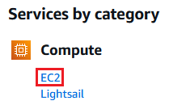
- Click “Launch instance”.

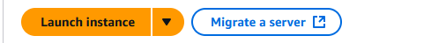

- Assign a name. Choose Amazon Linux and an AMI.

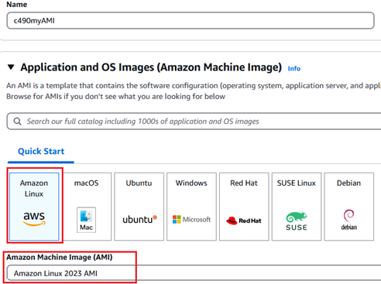

- Select an existing key or create a new key pair.

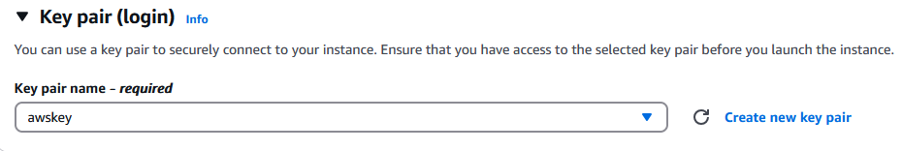

- Create a security group and allow SSH, HTTPS, and HTTP access.
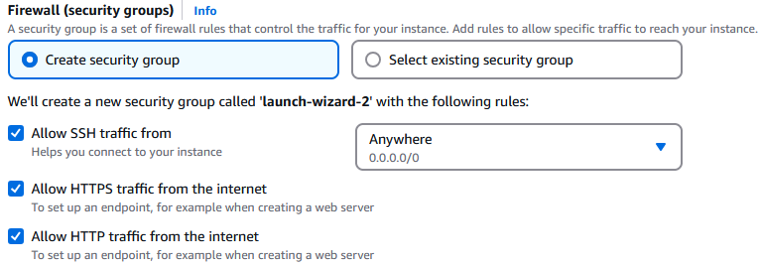
- Click on “Launch instance”.



Part 3. Install and Launch an Apache Web Server on EC2

- When launch is completed, click on the EC2 instance.

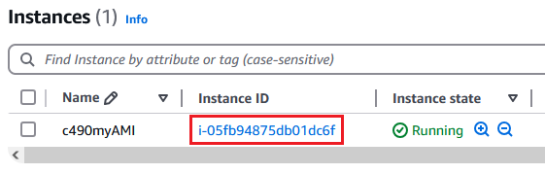

- Click on “Connect”.

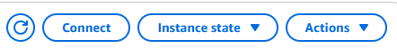

- Click “SSH client”.

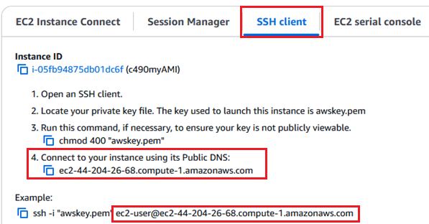

- Start Putty.
- In the Category pane, choose Session.
- In the Hostname box, paste the one you see in Connection Page (Step 23)

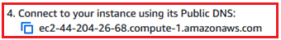

- Under Connection type, select SSH. The Port value is 22.
- In the Category pane, expand Connection, expand SSH, and then choose Auth, Credentials. Choose Browse. Select the .ppk file that you generated for your key pair before and choose Open.
- Click “Open” and you will be asked for user name. Enter: ec2-user. This can be found at Step 23.
- You are now connected to the Linux machine.
- Now, let’s run the following commands to install Apache web server and PHP.

$ sudo yum update -y
$ sudo yum install -y httpd php php-mysqli
$ sudo systemctl start httpd
$ sudo systemctl enable httpd

Part 4. Build a PHP Dashboard for Stock Tracking

- Start WinSCP and log onto the EC2 instance.
- Enter Host name, User name, which can be found at Step 23.
- Click “Advanced” and select authentication and pick the private key file you generated before. Click Login.

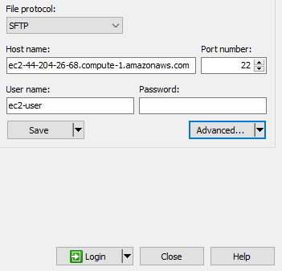

- Download file dashboard.php provided online.
- Open it and replace $bucket variable with your own value, which can be found at Step 4. In my case:

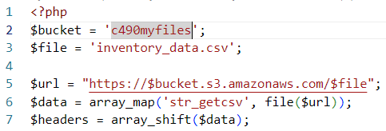

- Save the changes and upload the modified PHP file onto the user’s home directory.

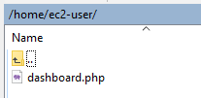

- Go back to Putty and run the following commands to move the php file to Apache's directory and set appropriate permissions.

$ sudo mv /home/ec2-user/dashboard.php /var/www/html/ # move
$ sudo chown apache:apache /var/www/html/dashboard.php # assign group
$ sudo chmod 644 /var/www/html/dashboard.php # assign permissions

- Open a web browser and enter the following URL.

http://<INSTANCE_PUBLIC_IP>/dashboard.php

- You need to replace <INSTANCE_PUBLIC_IP> with EC2’s public IP address, which can be found on the EC2’s instance page at AWS console.

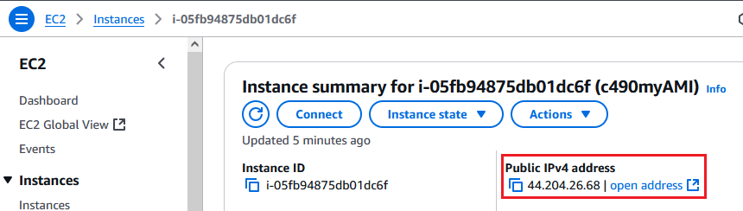
- You should see the following page.

